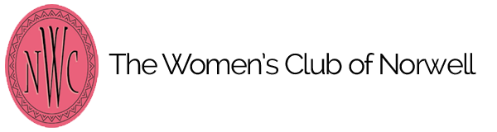
Any graduating High School senior attending a private school and a resident of Norwell is eligible to submit to pattinelson13@gmail.com. Deadline for submission by March 24, 2019.

Student Name:___________________________________________________________________
High School: __________________________ email:__________________________
phone: _______________________________
Mailing address:______________________________________________________________________

History of Community service/volunteer experiences and/or involvement in Clubs that support community service and volunteerism (include dates and description of your involvement)

Essay Submission: all submissions should by typed and at least one page.

Essay prompt: Choose a personal experience from your own life and explain how it has influenced your own development:

