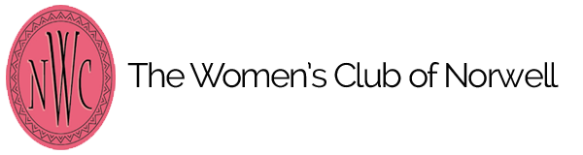
Any graduating High School senior attending a private/charter school and a resident of Norwell is eligible to submit this application to the Women’s Club of Norwell in
c/o pattinelson13@gmail.com. Deadline for submission by March 15, 2023
NORWELL HIGH SCHOOL STUDENTS, KINDLY SEND YOUR APPLICATIONS VIA GUIDANCE. DO NOT SEND THEM TO THE WOMEN’S CLUB DIRECTLY. Thank you.

Student Name:___________________________________________________________________
High School: __________________________ personal email:__________________________
phone: _______________________________
Mailing address:______________________________________________________________________

History of Community service/volunteer experiences and/or involvement in Clubs that support community service and volunteerism (include dates and description of your involvement)

Essay Submission: all submissions should by typed and at least one page.

Essay prompt: Choose a personal experience from your own life and explain how it has influenced your own development (1-2 pages in length):

